Prompted: This is my .CPP file for a project i am working on at the moment can you make a starting menu with this code please
Got a few errors so I prompted there’s errors with calling or passing game to figure out where the issue was, I eventually got the main menu screen working, and it actually looks cool!
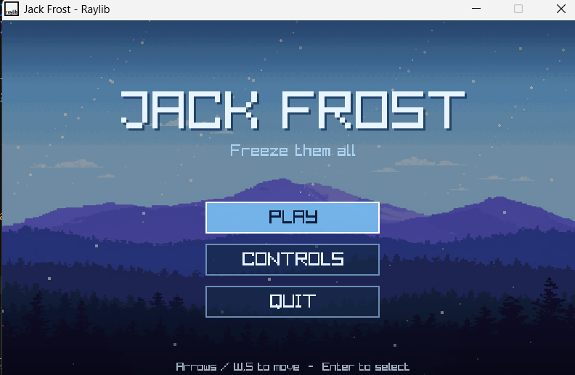
Fixed all the merge conflicts and pushed it up to git.
Prompted: this is my game. c and my game.h file I want the game to have ladders that are connected to the platforms if the ladders are able to reach the bottom without another platform underneath

Gave me a few bugs so I prompted :There is a few errors here what do I do???
There are still a few errors so I just prompted a message with the errors from the terminal and asked it to fix them for me
I finally got the ladders to work but there is a few errors with them so I need to fix it a bit

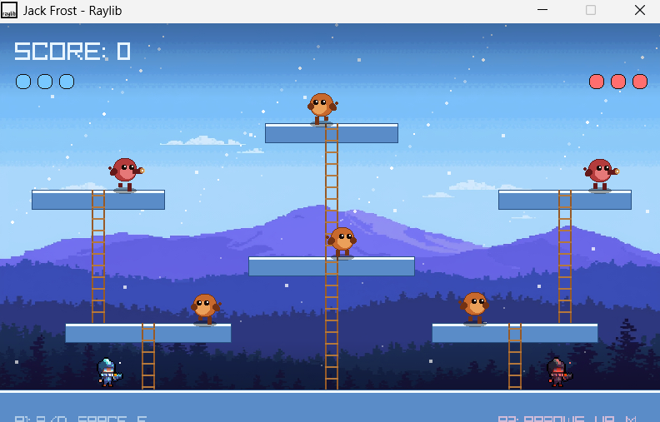
Prompted : I don't want the ladders on the bottom anymore because the player glitches into the floor. I don't want the player to fall off the ladder when they stop moving and the player doesn't actually go on top of the platforms so can you please fix that and give me the whole code for the files I need to change

The ladders still don’t let the player reach the top of the platform so I’m just going to prompt it to fix it
It works now the player can fully go up the ladder and stay on it when they stop moving

